STMP26 SENSATE Dublin 2026 — Student GENERAL Email
Dublin, 29 June – 4 July 2026 •
Contents
Email — General email to all participating students 1
Appendix Sample Projects Suggestions : 3
General Letter to TU Dublin Student Send 29th May 2026 7
LETTER WHICH EUROPEAN STUDENT GOT Around 20 May 2026 9
APPENDIX. Delivery Schedule (Subject to change not final ) 17

Email — General email to all participating students

Note (for sending): BCC all STMP26 participants, or use mail merge, so addresses stay private and there's no reply-all chain. Your address is only revealed to your teammates when you receive your team email.
Subject: STMP26 SENSATE-X — your team is on its way

1 June 2026

Dear all,
Thank you for confirming your place on the Short Term Mobility Programme STMP26 SENSATE-X, which runs in Dublin from 29 June to 4 July 2026. I am delighted you are taking part, and I thank the staff of all the partner universities for their help. Some of you may be asked by your university to complete documentation (a Learning Agreement) — if so, please do this as soon as you can. This is the general student email; it sets out your design task and the key information.

I will announce the teams shortly in a separate email (the team selection email )l. There will be 16 teams, identified by number. Once you receive your team number and your teammates' emails, please send them a few lines to introduce yourself. You should also arrange to meet online before Dublin — at least three meetings is a good idea — and organise these yourselves.
I know some of you have finished exams and others are starting soon. Your exams come first. There is plenty of time for the STMP, but keep exams as your priority.
You are expected to engage with the project GitHub site, which holds all the programme materials: github.com/gstockiltud/BIP26Dublin (the repository name is arbitrary — the event is the STMP, Short Term Mobility Programme). When and how you work through it is up to you. As a rough guide, we suggest around 30–35 hours of preparation for first-year students; those in later years may need less.
You have also been given a general information pack, included at the end of this email. If you haven't read it yet, please find time to do so soon — you'll see the same ideas come up again and again.
Your design challenge
Assume you have the basic NMEA program working and that you can use AI to help you code (a sample prompt is on GitHub). Your goal is to build an application that uses the Tenstar and Waveshare boards to take measurements on campus from the satellite signals decoded by the GNSS receiver (the NMEA data). The documentation shows sample screens using the TFT display. Once you have your measurements, upload them to a PC by any method you like — for example the board's built-in Bluetooth or WiFi.
I am deliberately not telling you which satellites to track or which measurements to take. The Appendix lists ideas from simple to ambitious — choose one or devise your own. You are all at different stages in your studies, so be ambitious but realistic. You are here to learn: you already know a lot, and as a team you will discover more.
Six things to keep in mind
- Exams come first. Those who have finished (the Irish students) can use the time to prepare.
- This is a learning and a social/cultural experience. There are no written exams; you'll be asked to give a presentation, and there may be a few easy GitHub exercises. Talk to people — including your team online before Dublin. Take part and try your best, and you'll receive a certificate at the end of the week. Above all, enjoy it.
- Decide as a team what to build, and agree it before you start detailed coding.
- Keep your first version simple, get it working, then build on it. Use the GitHub material — the starting quizzes on GNSS and NMEA, the basic NMEA program, and the wiring details and photographs in the introductory material.
- You're strongly encouraged to use AI, but you don't have to, and you may use any tool you like. I use Claude among others — use whatever suits you.
- As with any event, things may change, so watch your email and check GitHub for updates.
A note for the TU Dublin students: at every previous event — in Spain, Romania and Germany — the hospitality was second to none. Let's match it and give all our European partners a great experience of TU Dublin and Ireland.
For questions only your home university can answer, please contact them. To reach me, email Gerard.stockil@gmail.com. I'll send your team letter soon.
Best wishes, Gerry

Appendix Sample Projects Suggestions :

Good extension ideas for STMP26, organised by what's genuinely on the microcontroller versus a small add-on. The board is the Tenstar TS-ESP32-S3, so the truly on-board sensing is limited — but there's enough to make solid extensions, and the GNSS module itself is a rich "sensor" to exploit.
Using sensing that's actually on the ESP32-S3
1. Internal temperature logging tied to position. The S3 has a built-in die-temperature sensor. It reads chip temperature, not ambient — which is a nice teaching point about sensor limitations — but it's perfect for logging a value alongside GPS time and position.
cpp
float t = temperatureRead(); // Arduino-ESP32 core, °C from internal sensor
tft.printf("Chip: %.1f C\n", t);
// log: <UTC>, <lat>, <lon>, <t>
A worthwhile aside for students: the original ESP32 had a Hall-effect sensor; the S3 dropped it, so don't let them go looking for hallRead().
2. Capacitive touch as a no-extra-hardware UI. Use touch-capable GPIOs as buttons to cycle TFT screens, drop a waypoint, or start/stop logging — useful since the board has few physical buttons.
cpp
int v = touchRead(T1); // note: on S3 the reading rises when touched
if (v > THRESHOLD) markWaypoint();
3. ADC battery monitor. Read the battery/USB rail through an ADC pin and show a voltage or low-battery warning on the TFT. Practical embedded skill, and it makes the unit field-ready for the campus walk.
Using the GNSS receiver itself as the sensor (no extra hardware, ties straight to the brief)
4. Speed and distance tracker. Compute speed and cumulative distance from consecutive fixes using the haversine formula, displayed live on the TFT — a natural fit for a campus-walking exercise.
cpp
double haversine(double lat1,double lon1,double lat2,double lon2){
const double R=6371000.0, d2r=M_PI/180.0;
double dlat=(lat2-lat1)*d2r, dlon=(lon2-lon1)*d2r;
double a=sin(dlat/2)*sin(dlat/2)+cos(lat1*d2r)*cos(lat2*d2r)*sin(dlon/2)*sin(dlon/2);
return R*2*atan2(sqrt(a),sqrt(1-a)); // metres
}
5. Sky/SNR quality plot — the strongest "satellite measurement" extension. Parse the GSV sentences for per-satellite SNR, elevation and azimuth and draw an SNR bar chart or a simple sky plot on the TFT. Students can then measure the urban-canyon effect by comparing an open quad against a spot beside a tall campus building — a real, repeatable result that directly matches "measurements related to satellites."
6. Geofencing. Define campus zones (centre + radius, or simple polygons) and trigger an alert when entering/leaving. Good maths/CS content, all in software.
7. Bluettoh control of selected program via

Sample Group Project.

Group Project Plan
A Bluetooth (BLE) campus-measurement app on the Tenstar TS-ESP32-S3

Scope: a group of five, 25 hours across four days, having completed system design and reading beforehand. Target: stream live satellite/sensor measurements from the Tenstar board to the students' own phones over Bluetooth Low Energy, with no hardware beyond the board itself.
Feasibility verdict
Feasible, and comfortably so for the realistic target. With the design and reading already done, the slowest and least predictable work is removed before the clock starts. Getting the board to notify a value to a phone is a well-trodden path a focused pair can complete in an afternoon; the rest of the time goes on real data, integration and a simple app. The main risk is not capability but scope discipline and keeping all five members productive in parallel.
Board-specific facts that shape the plan
Board | Tenstar TS-ESP32-S3 (the only hardware required)
Bluetooth | BLE only – the S3 has NO Bluetooth Classic. Do not use BluetoothSerial / “Serial Bluetooth Terminal”.
BLE library | Bundled BLEDevice (File > Examples > ESP32 BLE Arduino) – nothing extra to install. NimBLE-Arduino is a lighter alternative if memory gets tight.
GNSS | Waveshare LC29H(AA) – jumper Position B, 115200 baud
GNSS UART pins | GPS_RX = 17, GPS_TX = 18
On-board TFT | TFT_CS = 7, TFT_DC = 39, TFT_RST = 40 (shows what is being transmitted)
On-board sensor | ESP32-S3 internal temperature via temperatureRead() (no Hall sensor on S3)
Phone app for testing | nRF Connect for Mobile (free, iOS + Android) – guaranteed fallback
The data contract (agree this on Day 1)
So the firmware team and the app team can work in parallel without waiting for each other, fix the BLE interface first:
- Name: Device advertises as STMP26-<team> so each group finds its own board.
- Service: One custom Service UUID (generate at uuidgenerator.net).
- Characteristic: One Characteristic with the NOTIFY property carrying a UTF-8 string.
- Payload: A single comma-separated line, e.g. "53.2859,-6.3733,41.2,9" = lat, lon, chipTempC, sats, sent once per second.
This keeps both the board code and the phone code trivial: the board just builds a string and calls notify(); the app just splits the string on commas.
The very simple app (MIT App Inventor, one screen)
No native Android/iOS coding. Use MIT App Inventor (free, browser-based) with its official BluetoothLE extension. A single screen is enough:
- Connect: a “Scan & Connect” ListPicker that lists nearby BLE devices and connects to the chosen one;
- Status: a status Label (Disconnected / Connected);
- Live values: four large Labels showing Lat, Lon, Temp and Sats, updated as data arrives;
- Log: a “Start / Stop logging” Button that appends each received line to a list;
- Export: a “Share CSV” Button that writes the log to a file and shares it (e.g. to email or the PC).
Block logic, in plain terms:
- ListPicker.BeforePicking → start BLE scan; show found devices.
- ListPicker.AfterPicking → connect to the selected device.
- BluetoothLE.Connected → set status to Connected; register for strings on the agreed Service/Characteristic UUIDs.
- BluetoothLE.StringsReceived → split the line on commas; put the four parts into the four Labels; if logging is on, add the line to the log list.
- Share button → save the list as campus_data.csv and open the share sheet.
That is a genuinely complete, useful app a student can build in a few hours, and it ties straight into the challenge’s “upload your results” requirement. If they finish early, adding a simple line-graph of SNR or temperature is the natural stretch.
Team split (keep all five busy)
- 1: BLE firmware – the server, service, characteristic and notify() on the Tenstar board.
- 2: Phone app – nRF Connect proof first, then the App Inventor screen above.
- 3: Data + PC path – the CSV format and the WiFi upload to a PC (BLE is poor for bulk transfer).
- 4: Integration + test – BLE + GNSS + TFT running together; the open-quad vs tall-building measurement.
- 5: Documentation + demo – README, wiring notes, results write-up, final presentation.
Four-day plan
Day | Focus | Board-specific milestone
Day 1 | Setup & interface | Toolchain on every laptop (see gotchas below); agree Service/Characteristic UUIDs and CSV format; get the bundled BLE_server example notifying a DUMMY value to a phone in nRF Connect.
Day 2 | Real data on the board | Replace the dummy value with live GPS + chip temperature; show the same string on the on-board TFT so the board displays what it transmits.
Day 3 | App + pipeline | Build the App Inventor screen and connect to the board; implement the WiFi-to-PC bulk upload of the logged CSV.
Day 4 | Field test & write-up | Open-quad vs tall-building SNR/fix measurement; bug-fix; documentation and demo. Keep new features OUT of the last half-day.
Tenstar S3 gotchas to warn them about
- In the Arduino IDE select board “ESP32S3 Dev Module” and enable “USB CDC On Boot”, or the Serial Monitor stays silent over the native USB port – the classic Day-1 time-sink.
- BLE quirks (notify subscriptions, MTU size, occasional reconnection oddities) eat more debugging time than the happy path suggests.
- Confirm the LC29H jumper is in Position B and the module is at 115200 baud before blaming the code.
- Always get the simplest end-to-end version working first (board → nRF Connect → one value) as a guaranteed fallback before adding the custom app.

General Letter to TU Dublin Student Send 29th May 2026
STMP Sensate Dublin 26 — Invitation to Participate Short-Term Mobility Programme: SENsors and Software for Applications and Technological Education, Dublin 2026
Friday 29 May 2026
Dear TU Dublin Student,
Dear Abdul, Adriana, Ali, Aya, Aydar, Christian, Dovydas, Emma, Eoin, Joel, Kevin, Kiril, Kyrlo, Max, Matas, Mia, Mohammed, Muhammad, Nery, Niki, Oisín, Ostap, Ray, Richard, Rokas, Sean, Shannon, Thanh Tao, Tommy, and Tony,

You have been selected for STMP Sensate Dublin 26, running on the TU Dublin Tallaght Campus from Monday 29 June to Friday 3 July, with a social day on Saturday 4 July and an online training phase during June. Full details: https://github.com/gstockiltud/BIP26Dublin
Congratulations , I hope you all can confirm attendance There is a waiting list of interested students, so please reply by 17.00 Tuesday 2 June 2026 (or earlier if you can). If I do not hear from you by then, I will assume you are not available and may offer your place to someone else.
Reply to Gerard.stockil@tudublin.ie with one of the following:
"I accept the invitation for the STMP and am available on the dates stated. I will participate in the online training phase and represent the university to the best of my abilities and do my best to make guest students and staff from Europe as welcome as possible."
OR
"I am no longer available for the STMP."

If you accept, please read on.
Teams will be formed on or about 3 June — watch your email. Each team mixes students from all the partner universities, and sometimes from different TU Dublin campuses. As a TU Dublin host student, please reach out to your team members from the partner universities: a short welcome message and a suggestion for an online introductory meeting is ideal. How you organise it is up to you.
Those who accept will also be asked to complete some paperwork over the following weeks (the learning agreement and related forms). Please return these as soon as you receive them.
Programmes like Sensate are about seeing the bigger picture — meeting people with different life experiences and becoming better engineers and creators. GNSS (Global Navigation Satellite Systems) is a theme that touches every discipline, and this could be your first step towards real expertise in the area.
This is the fourth Sensate summer school, built on the work of professionals across six partner universities:
- UPV, Valencia (Spain) — a leading Mediterranean technical university; hosted Sensate 2023.
- UTCN, Cluj-Napoca (Romania) — a foremost academic and technology city in Transylvania; hosted Sensate 2024. "Silicon Valley of Transylvania," with multiple research centres including an Automotive Research Centre.
- H-DA, Darmstadt (Germany) — Germany's "City of Science," home to ESA's European Space Operations Centre; hosted Sensate 2025. Student work in Robotics and multiple cross over sectors
- UniCas, Cassino (Italy) — new this year — in the shadow of the abbey of Monte Cassino, strong ties to automotive industry, many of 2026 student study Telecomms and they specialise in Radar and many areas.
- FH Campus Wien (Austria) https://www.hcw.ac.at/ — new this year — One of Austria's largest universities of applied sciences with a very interesting Advanced Manufacturing , in Vienna.
- TU Dublin (Ireland) —host in 2026, a UNESCO City of Literature. Campuses on the North, Centre and South of Dublin make it one of Europe’s largest suppliers of graduate engineers.

Broad Description of Programme, Aims and learning outcomes
The aim is for undergraduate technologists and their academic staff to work together to develop better engineers for Europe. After participating in the virtual (online) phase and the mobility phase, students will develop their knowledge in the following areas:
- Embedded systems & hardware — ESP32-S3, Arduino IDE, wiring
- GNSS principles & multi-constellation operation — NMEA, GPS/Galileo/GLONASS/BeiDou, HDOP
- Galileo OSNMA authentication — basic introduction, spoofing awareness
- Real-world measurement & data collection — field exercise, logging, comparison
- AI-assisted software development — introductory AI coding tools, prompt engineering
- Version control & collaborative practice — introduction to GitHub, team workflows
- Semiconductor industry awareness — SITE VISIT, the enabling role of semiconductors in GNSS and high-tech
- International professional collaboration — teamwork, professional integrity, cultural enhancement

To prepare, you can try the GNSS and NMEA quizzes on the GitHub site
https://github.com/gstockiltud/BIP26Dublin/tree/main/quizzes
, and consider buying a Tenstar board (about €15) to practise on — it can also be used for follow-on projects in your studies. Delivery time is three weeks, but it usually arrives earlier
https://www.aliexpress.com/item/1005006590631744.html
In the event week we will have receiver board for each time and some controller board. Full instruction of the prototype is on GitHib see the Getting Started Guide at https://github.com/gstockiltud/BIP26Dublin/tree/main/docs
Any questions, just email me.
Enjoy the bank holiday weekend.
Best wishes,
Gerry
Gerard.stockil@tudublin.ie
STMP Sensate Dublin 26
Short-Term Mobility Programme:
SENsors and Software for Applications and Technological Education,
Dublin 2026

Below is the letter the EU students have received, it contains technical details please read it

LETTER WHICH EUROPEAN STUDENT GOT Around 20 May 2026
From : Gerard Stockil , TU Dublin Gerard.stockil@tudublin.ie
Subject: Getting Started on the Blended Phase for Sensate X 2.0 Short Term Mobility Program Dublin
22 May 2026
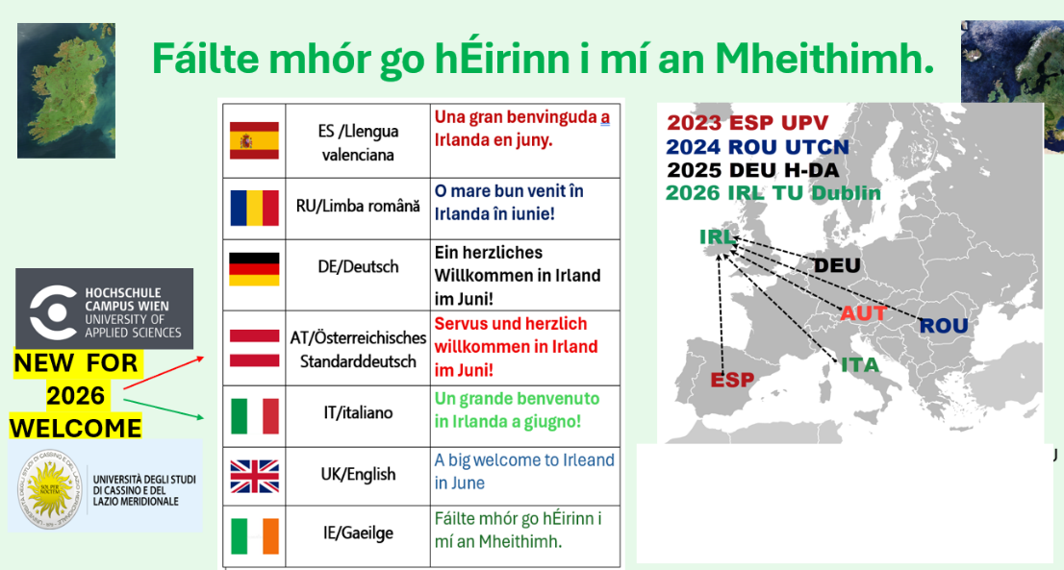

Dear Student,
We are delighted that you will be joining us in Ireland! This email will get you started on the online (blended) phase of the Short-Term Mobility Programme (STMP) — SENSATE-X 2.0.
All learning materials are hosted on the GitHub site:
https://github.com/gstockiltud/BIP26Dublin which first was pasted in April
The site may be updated and there is already plenty to explore.
Quizzes

Two interactive quizzes are available at these are a good place to start :
https://github.com/gstockiltud/BIP26Dublin/tree/main/quizzes

1. Galileo / GNSS Quiz — covers the basics of Global Navigation Satellite Systems.
Quiz: https://gstockiltud.github.io/BIP26Dublin/quizzes/BIP26_Galileo_Quiz.html
Tutorial: A tutorial is available at https://github.com/gstockiltud/BIP26Dublin/blob/main/quizzes/BIP26_Galileo_Tutorial.pdf
Copy and paste following link to a browser to run the quiz.
https://gstockiltud.github.io/BIP26Dublin/quizzes/BIP26_Galileo_Quiz.html

You can attempt quizzes as often as you like.
2. NMEA Quiz — covers the NMEA communication protocol used by GNSS receivers.
A tutorial is also available on the GitHub site.)
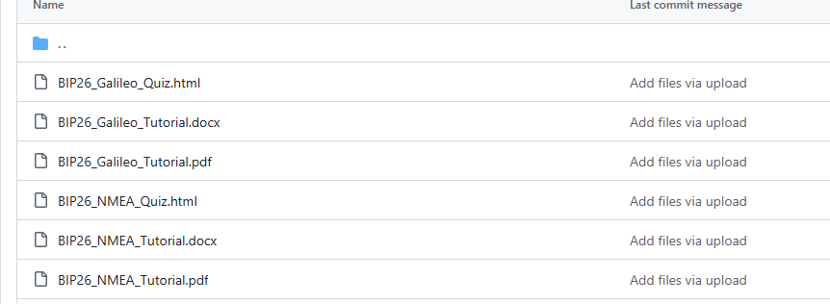
Quiz: https://gstockiltud.github.io/BIP26Dublin/quizzes/BIP26_NMEA_Quiz.html
(
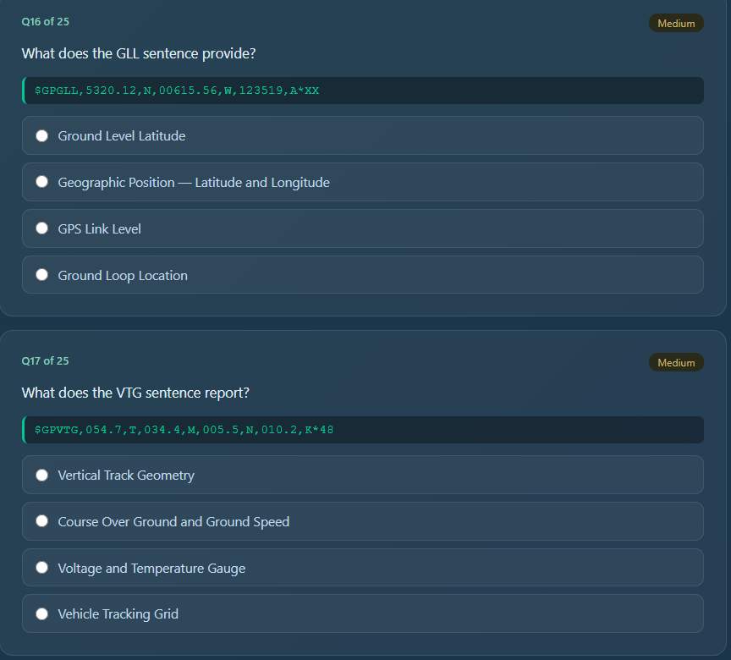
You can attempt each quiz as many times as you like.
DRAFT WEEKLY SCHEDULE SUBJECT TO CHANGE

About NMEA and Your Project.
The Project
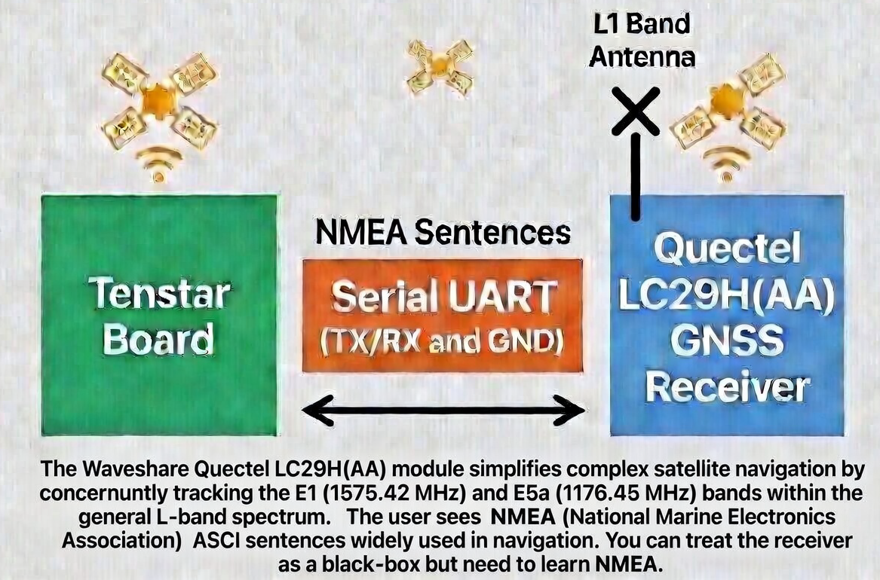
The hardware platform is the TenStar ESP32-S3 microcontroller as describe in the following link (
https://www.aliexpress.com/item/1005006590631744.html?src=google&src=google&albch=shopping&acnt=615-992-9880&isdl=y&slnk=&plac=&mtctp=&albbt=Google_7_shopping&aff_platform=google&aff_short_key=_oFgTQeV&gclsrc=aw.ds&albagn=888888&ds_e_adid=&ds_e_matchtype=&ds_e_device=c&ds_e_network=x&ds_e_product_group_id=&ds_e_product_id=en1005006590631744&ds_e_product_merchant_id=5080937310&ds_e_product_country=IE&ds_e_product_language=en&ds_e_product_channel=online&ds_e_product_store_id=&ds_url_v=2&albcp=22476408939&albag=&isSmbAutoCall=false&needSmbHouyi=false&gad_source=1&gad_campaignid=22476413733&gbraid=0AAAAA_TvRHou8xPTFMtEc__aM09QhAA43&gclid=Cj0KCQjw_b_QBhCSARIsAP6hR4eVBkjCDIAWwM1GMqzQ90nJYie4Nc3loda65HhNNBqeyqY7usKtUJsaApOhEALw_wcB

) This system will be connected to the Waveshare Quectel LC29H(AA) GNSS receiver ( https://www.waveshare.com/lc29h-gps-hat.htm?sku=25278 this kit includes an antenna and a antennae connector, it also mentions the Raspberry Pi, we will not be using it with Raspberry Pi, it must be the AA version see previous ink .) The Tenstar board has a 1.14” TFT display and many peripherals which you can use to extend the project. Full instruction on how to wire these are in GitHub, see https://github.com/gstockiltud/BIP26Dublin/tree/main/docs .
.
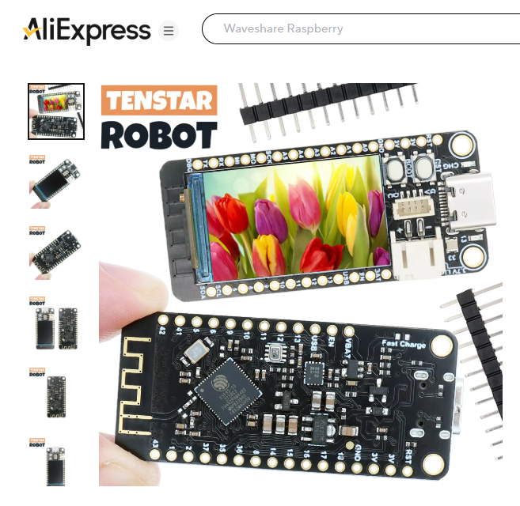
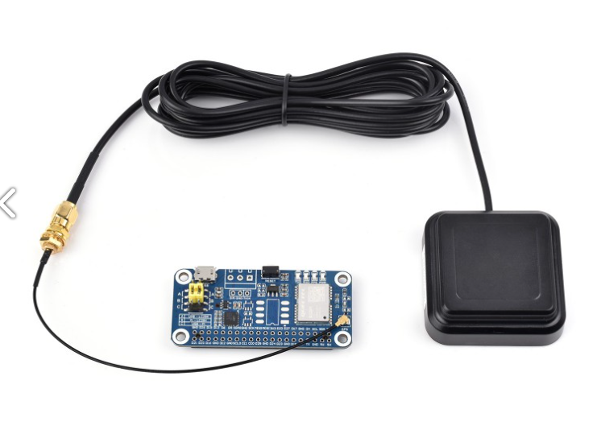
Refer to https://github.com/gstockiltud/BIP26Dublin/tree/main/docs for full details. The following is summary
You will need two USB cable, A UBS A to Type C cable to power the TenStar board and a USB Type A to MicroUSB cable to power the Waveshare board. You will also need three 30 cm Dupont jumper wire (male-to-female) ( Header pin to socket connector ) Please use the three colours Black ., Blue and Yellow only. There is no shared power supply between both boards, only a common ground, . Power both USB cables from the same PC or the same HUB. Details on how to wire this up are summarised in the picture below and details on GitHub. The three wires implement a serial interface which will receive NMEA data from the satellites , this you will use to build your project. The following diagram should be used for guidance only, full instruction of GitHub.

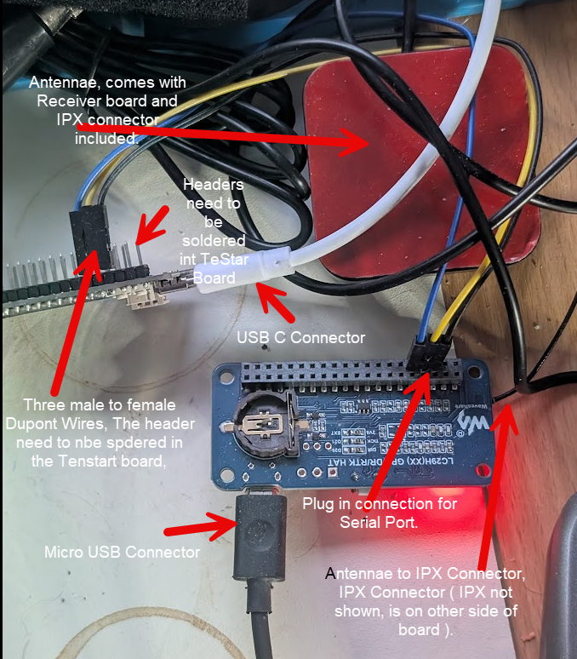
Use As Rough Guide Only, details on Github

Each team will define their own application — based on a simple NMEA reception program shown below
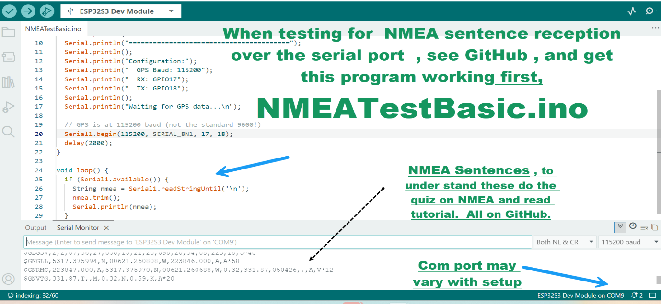

You will get this working on day one, if you have the hardware before then you can try it out.
One way of extending the project is, for example, recording the latitude and longitude of locations on a campus walk and uploading the data to a host machine, then developing the theory during the blended phase and implementing it in Dublin. Teams will then test and refine their application in Dublin and present their work as a group on the final day.

A sample display from an extended project which shows the PVT (position velocity and time ) command display . You might use AI to help you code this but describing it is important.
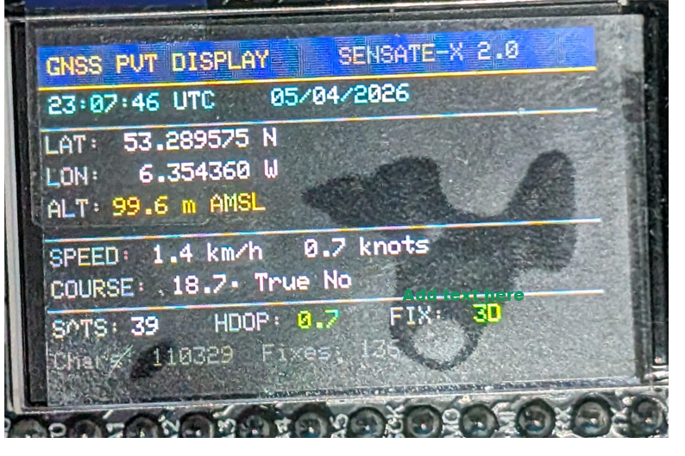
The application will be based on some basic Arduino programs that process NMEA sentences, which are described on GitHub. Note that the GitHub material will be updated periodically, with new material and clarifications added as required.
All the programs are based on an understanding of the basic NMEA receiver program sketch shown below. This depends on understanding what the NMEA sentences mean, and there are a training document and quiz to help with this. There are also many other web resources available which you can search for.
It is up to the Teams to define what they want to do, using the on-chip peripherals on the microcontroller is recommended

NMEA (National Marine Electronics Association) is a standard text-based format used by GPS/GNSS receivers to transmit data such as position, time, speed, altitude, and satellite information. A typical sentence looks like:
$GPGGA,123519,4807.038,N,01131.000,E,...
Messages are ASCII text, comma-separated, and sent over serial links such as UART or USB. During the project, teams will work with a basic Arduino program to receive and decode NMEA data, examining sentence types such as:
GGA — Position and altitude
RMC — Time, position and speed
GSV — Satellites in view
VTG — Course and speed

If you complete the NMEA quiz you will become familiar with the above.

We look forward to welcoming you to TU Dublin Tallaght Campus on 29th June 2026 we meet at 10.00 AM.
Tallaght Campus (Dublin 52.228 ° N, - 6.3621 • W)
Details at https://www.tudublin.ie/explore/our-campuses/tallaght/ and tram called Luas in Dublin will get you from the city centre to Tallaght Campus in around 60 minutes. Some of you may be staying in the City Centre, the closest stops are usually Jervis or Abbey St, and you get the Tallaght tram ( last stop Tallaght ), from there is a 10-minute walk to the campus Return tickets cost €5.20.

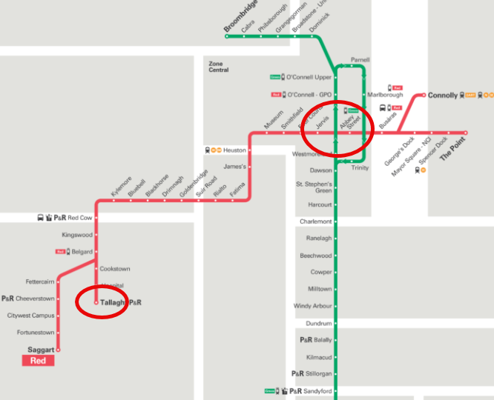
Please get back to me at Gerard.stockil@tudublin.ie if you have any questions. Looking forward to meeting you all.
Best wishes,
Gerry , Gerard Stockil
Sensate X 2.0 Short Term Mobility Program Coordinator
TU Dublin, Tallaght Campus

APPENDIX. Delivery Schedule (Subject to change not final )

STMP Sensate X 2.0 — Programme Schedule
TU Dublin Tallaght Campus · 29 June – 4 July 2026
Hardware: TenStar ESP32-S3 · Waveshare LC29H(AA) GNSS module · Galileo OSNMA
Partner universities: TU Dublin (IE) · H-DA Darmstadt (DE) · UTCN Cluj-Napoca (RO) · UPV Valencia (ES) · FH Campus Wien (AT) · University of Cassino (IT)
Time | Session | Type
Monday 29 June 2026 — Late start — travel recovery
10:00–10:30 | Welcome & introductions  BISS overview · partner university introductions · programme briefing | Lecture
10:30–10:50 | Break | Break
10:50–11:10 | Industry introduction — Tokyo Electron (TEL)  Semiconductors: making GNSS possible · how TEL technology underpins modern positioning systems · 20-minute keynote | Industry
11:10–12:30 | Arduino IDE setup & first program  Library installation · RGB NeoPixel · troubleshooting | Lab
12:30–14:30 | Lunch | Lunch
14:30–15:30 | TFT display basics  Text output · colours · simple graphics · 'Hello [Name]' program | Lab
15:30–15:50 | Break | Break
15:50–17:00 | GPS connection & NMEA introduction  Wire LC29H module (Yellow/Blue/Black) · NMEA sentences on Serial Monitor | Lab
Teaching: ~5 hrs · Success metric: NeoPixel + TFT working for all students
Tuesday 30 June 2026 — Full day — GNSS fundamentals
09:00–09:30 | Day 1 recap & troubleshooting  Resolve outstanding setup issues · share successes | Lecture
09:30–10:30 | TinyGPSPlus library  Parse NMEA · extract lat/lon, satellites, speed, altitude · display on TFT | Lab
10:30–10:50 | Break | Break
10:50–12:30 | Multi-GNSS exploration  GPS · Galileo · GLONASS · BeiDou sentences · satellite count per system · Serial Plotter visualisation | Lab
12:30–14:30 | Lunch | Lunch
14:30–15:30 | Firmware version checking  Run firmware checker · record versions · discussion: what makes firmware OSNMA-capable? | Lab
15:30–15:50 | Break | Break
15:50–17:00 | HDOP & position accuracy  Display HDOP gauge on TFT · compare indoor vs outdoor fix quality | Lab
Teaching: ~6.5 hrs · Success metric: Lat/lon + multi-constellation live on TFT
Wednesday 1 July 2026 — Half day — TEL site visit afternoon
09:00–09:30 | Day 2 recap  Group Q&A · consolidate GNSS concepts | Lecture
09:30–10:30 | Galileo OSNMA — concepts  Why OSNMA? · TESLA chain · ECDSA keys · spoofing awareness | Lecture
10:30–10:50 | Break | Break
10:50–12:30 | Campus GNSS field measurement  Outdoor walk · collect position data · log to SD or Serial · group data comparison | Field
12:30–13:30 | Lunch — early, for departure | Lunch
13:30–17:30 | Visit to Sponsor — Tokyo Electron (TEL), Santry  Guided visit to TEL Ireland · semiconductor fabrication technology · industry perspectives · GNSS and precision measurement in manufacturing | Site Visit
17:30 onwards | Social evening — students' own time  City centre optional · informal dinner | Social
Teaching: ~3.5 hrs · Site visit: ~4 hrs (TEL Santry) · Success metric: Field data collected · OSNMA concept understood
Thursday 2 July 2026 — Full day — integration & advanced topics
09:00–09:30 | Field data analysis  Review Wednesday measurements · accuracy discussion · group findings | Lecture
09:30–10:30 | GitHub workflow  BISS repository · commit · push · README · each student makes a contribution | Lab
10:30–10:50 | Break | Break
10:50–12:30 | AI-assisted coding with ESP32-S3  Using AI tools to develop/debug Arduino sketches · prompt engineering for embedded code | Lab
12:30–14:30 | Lunch | Lunch
14:30–15:30 | Group mini-project work  Teams finalise demonstration sketch · prepare short presentation · GitHub commit | Lab
15:30–15:50 | Break | Break
15:50–17:00 | Guest presentation — TEL Ireland  Tokyo Electron · semiconductor technology · industry career perspectives | Industry
Teaching: ~6.5 hrs · Success metric: GitHub commit from every student · mini-project working
Friday 3 July 2026 — Early finish — student presentations & closing
09:00–09:30 | Final preparation  Teams polish demos · last GitHub push | Lab
09:30–10:30 | Student presentations (part 1)  Groups 1–3 present GNSS mini-projects · peer Q&A | Lecture
10:30–10:50 | Break | Break
10:50–12:00 | Student presentations (part 2)  Groups 4–6 present · peer Q&A · best project recognition | Lecture
12:00–13:00 | Reflection & closing ceremony  Partner university reflections · certificates · group photo · closing remarks | Closing
13:00–14:00 | Farewell lunch | Lunch
Teaching: ~4.5 hrs · Success metric: All groups presented · certificates issued
Saturday 4 July 2026 — Social day — no technical activities
All day | Cultural & social day  An important part of the Erasmus+ BISS experience. No technical programme. | Social
Legend
Lecture Formal instruction / group discussion Lab Hands-on Arduino / ESP32 practical work
Industry Tokyo Electron (TEL) contribution Field Outdoor GNSS measurement activity
Site Visit Tokyo Electron Ireland, Santry Social Cultural exchange / informal programme
Sponsor acknowledgement: BISS 2026 is supported by Tokyo Electron (TEL Ireland) and the EEE department of TU Dublin . Thanks to TU Dublin Blanchardstown Camous for arranging TEL sponsorship and their expertise in GNSS. Thanks to colleagues at all campus for their support.

